INTEGRATION OF GITHUB WITH JENKINS:

1. Download GIT:
   1. Download git from <https://git-scm.com/downloads>
   2. After installing GIT go to cmd and enter git, if you get git is not recognized internal or external command the download <https://git-scm.com/download/win> and install it.
   3. Create a folder for your git projects and navigate to this folder from command line and enter “git init” it should return “initialized existing Git repository in D:/Git_Project/.git/”. And you will get .git(hidden) folder in repository folder: 
   4. Create your files under Dummy Project folder and save it.
   5. In cmd run “git status” command it should return you: 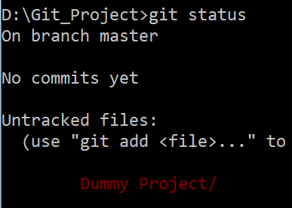x`
2. Create a GIT account on <https://github.com/>
3. Login and create a new repository

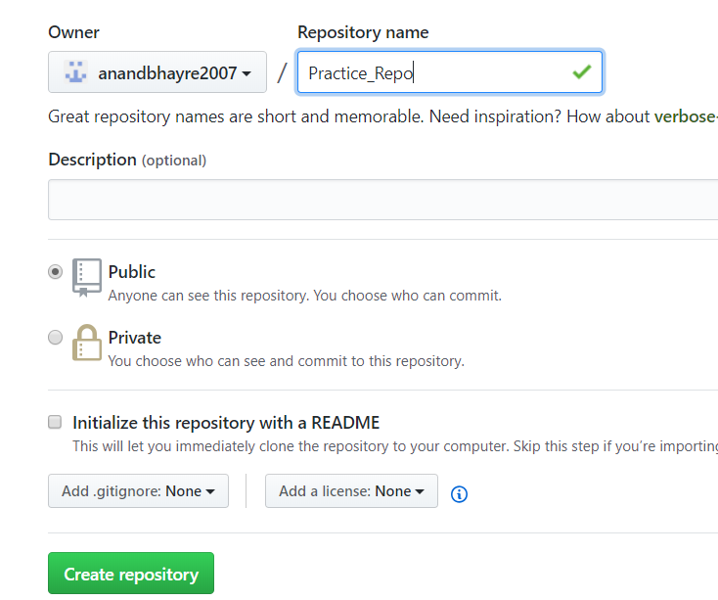

1. Now you have to register your username and email id to GIT HUB on your machine by using below command.
   1. : git config --global user.name "anandbhayre2007"
   2. git config --global user.email [anandbhayre2007@gmail.com](mailto:anandbhayre2007@gmail.com)
   3. It will open a pop up for username and password pls enter your username and passwords
2. Now add your files to staging repository: git add .
3. Now add to local repository: git commit -m “first commit”
4. Now add it to your github repository

7.1: git remote add origin <https://github.com/anandbhayre2007/Practice_Repo.git>

7.2: git push -u origin master

8. 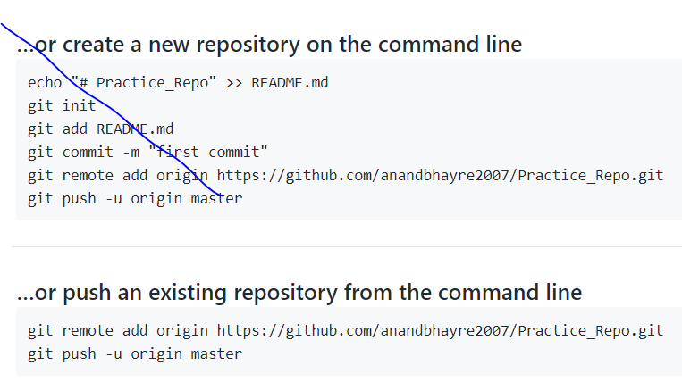

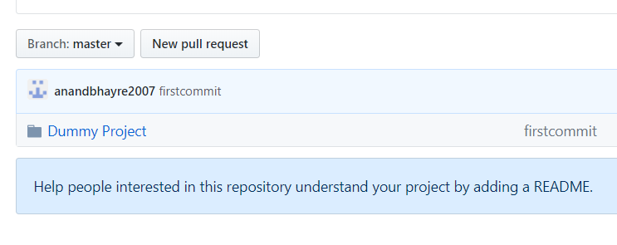

Jenkins set up:

1. Download Jenkins .war file (long term support) from <https://jenkins.io/download/>
2. Open command prompt and navigate to the folder where Jenkins.war file is sitting.
3. Execute “java -jar Jenkins.war” command in cmd.
4. Copy the password showing in cmd
5. Once you get Jenkins is fully up and running in cmd go to <https://localhost:8080>
6. You can use username as admin and password you copied in step 4
7. For first time it will ask you to install suggested plugin and create user
8. Now you need to set up path for JDK and Maven, so click on manage Jenkins→ 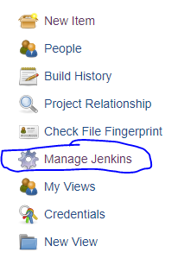
9. Now scroll down and click on Global tool configuration: 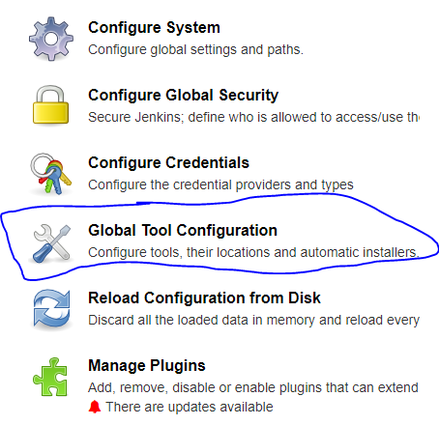
10. 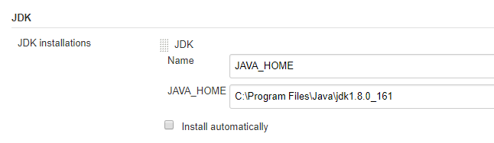
11. 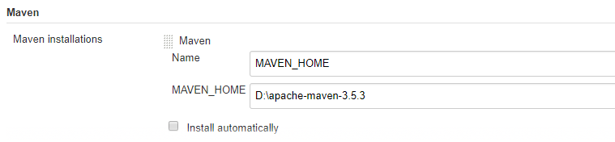
12. Click on Apply and Save
13. Again scroll on Manage Jenkins page and click on Manage Plugins → Click on Available → Search maven plugin → you will get “Maven Integration”→Check the checkbox and click on install without restart. 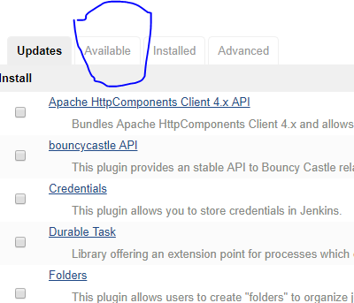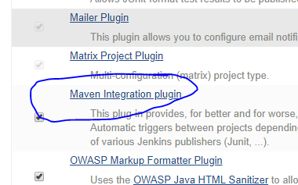
14. After successful installation click on Jenkins icon 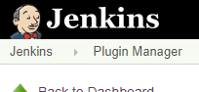it will navigate you to home page.
15. Click on new iteam→Enter Projectname (Any name)→Click on Maven project→Click on ‘OK’ button displayed on bottum screen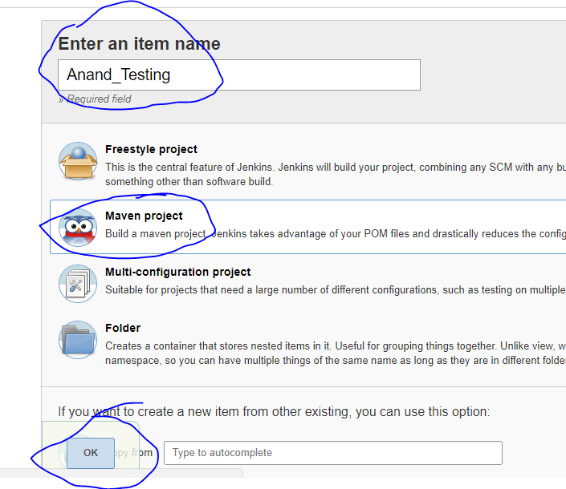
16. Scroll down till you Build section: 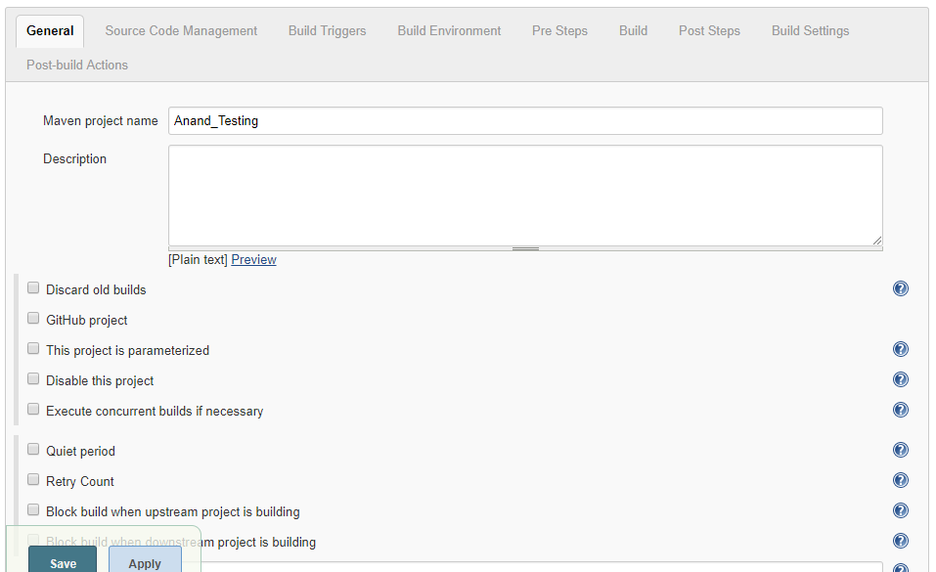
17. Enter concreate pom.xml path and enter goals, apply and save
18. 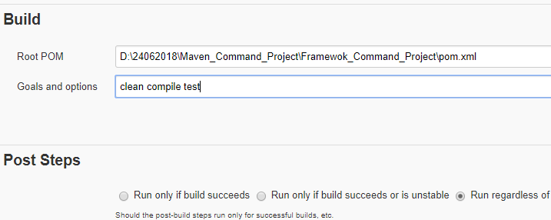
19. Click on build now, it will start execution
20. For periodically execution: Go to dashboard→Select your project→Click on configure→scroll down till you get Build triggers option:
21. 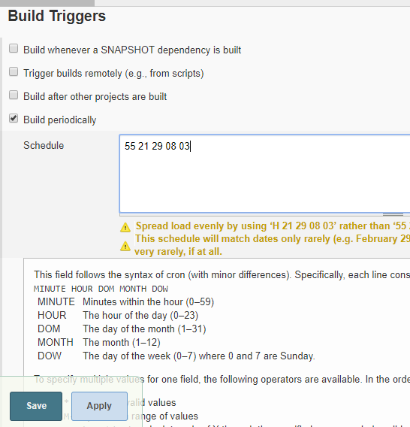

Jenkins set up for GIT:

1. Download GitSCM plugins from plugin manager: 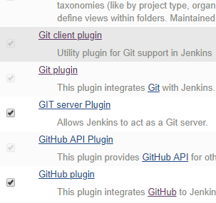
2. Under source code select git radio button:
3. 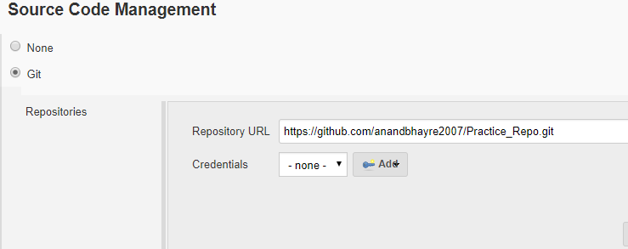
4. Under build triggers you can select Poll Scm and set the timing:
5. 